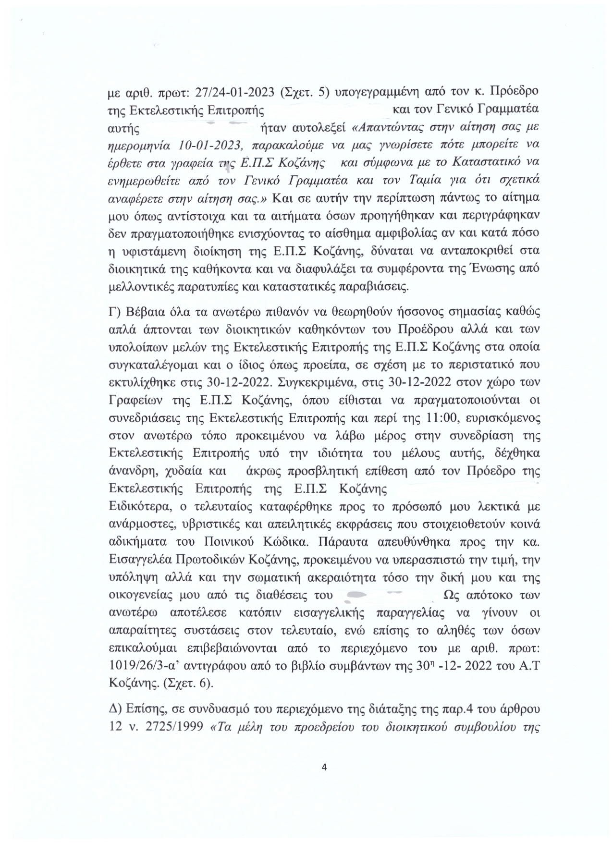

[**Click to BUY NOW**](http://www.tracker-software.com/product/pdf-xchange-editor)

[**!**](http://www.tracker-software.com/product/pdf-xchange-editor)

[**P**](http://www.tracker-software.com/product/pdf-xchange-editor)

[**D**](http://www.tracker-software.com/product/pdf-xchange-editor)

[**F**](http://www.tracker-software.com/product/pdf-xchange-editor)

[**-**](http://www.tracker-software.com/product/pdf-xchange-editor)

[**X**](http://www.tracker-software.com/product/pdf-xchange-editor)

[**C**](http://www.tracker-software.com/product/pdf-xchange-editor)

[**h**](http://www.tracker-software.com/product/pdf-xchange-editor)

[**a**](http://www.tracker-software.com/product/pdf-xchange-editor)

[**n**](http://www.tracker-software.com/product/pdf-xchange-editor)

[**g**](http://www.tracker-software.com/product/pdf-xchange-editor)

[**e**](http://www.tracker-software.com/product/pdf-xchange-editor)

[**E**](http://www.tracker-software.com/product/pdf-xchange-editor)

[**d**](http://www.tracker-software.com/product/pdf-xchange-editor)

[**i**](http://www.tracker-software.com/product/pdf-xchange-editor)

[**t**](http://www.tracker-software.com/product/pdf-xchange-editor)

[**o**](http://www.tracker-software.com/product/pdf-xchange-editor)

[**r**](http://www.tracker-software.com/product/pdf-xchange-editor)

[**w**](http://www.tracker-software.com/product/pdf-xchange-editor)

[**w**](http://www.tracker-software.com/product/pdf-xchange-editor)

[**w**](http://www.tracker-software.com/product/pdf-xchange-editor)

[**.**](http://www.tracker-software.com/product/pdf-xchange-editor)

[**t**](http://www.tracker-software.com/product/pdf-xchange-editor)

[**r**](http://www.tracker-software.com/product/pdf-xchange-editor)

[**a**](http://www.tracker-software.com/product/pdf-xchange-editor)

[**c**](http://www.tracker-software.com/product/pdf-xchange-editor)

[**k**](http://www.tracker-software.com/product/pdf-xchange-editor)

[**e**](http://www.tracker-software.com/product/pdf-xchange-editor)

[**r**](http://www.tracker-software.com/product/pdf-xchange-editor)

[**-**](http://www.tracker-software.com/product/pdf-xchange-editor)

[**s**](http://www.tracker-software.com/product/pdf-xchange-editor)

[**o**](http://www.tracker-software.com/product/pdf-xchange-editor)

[**f**](http://www.tracker-software.com/product/pdf-xchange-editor)

[**t**](http://www.tracker-software.com/product/pdf-xchange-editor)

[**w**](http://www.tracker-software.com/product/pdf-xchange-editor)

[**a**](http://www.tracker-software.com/product/pdf-xchange-editor)

[**r**](http://www.tracker-software.com/product/pdf-xchange-editor)

[**e**](http://www.tracker-software.com/product/pdf-xchange-editor)

[**.**](http://www.tracker-software.com/product/pdf-xchange-editor)

[**c**](http://www.tracker-software.com/product/pdf-xchange-editor)

[**o**](http://www.tracker-software.com/product/pdf-xchange-editor)

[**m**](http://www.tracker-software.com/product/pdf-xchange-editor)

[**Click to BUY NOW**](http://www.tracker-software.com/product/pdf-xchange-editor)

[**!**](http://www.tracker-software.com/product/pdf-xchange-editor)

[**P**](http://www.tracker-software.com/product/pdf-xchange-editor)

[**D**](http://www.tracker-software.com/product/pdf-xchange-editor)

[**F**](http://www.tracker-software.com/product/pdf-xchange-editor)

[**-**](http://www.tracker-software.com/product/pdf-xchange-editor)

[**X**](http://www.tracker-software.com/product/pdf-xchange-editor)

[**C**](http://www.tracker-software.com/product/pdf-xchange-editor)

[**h**](http://www.tracker-software.com/product/pdf-xchange-editor)

[**a**](http://www.tracker-software.com/product/pdf-xchange-editor)

[**n**](http://www.tracker-software.com/product/pdf-xchange-editor)

[**g**](http://www.tracker-software.com/product/pdf-xchange-editor)

[**e**](http://www.tracker-software.com/product/pdf-xchange-editor)

[**E**](http://www.tracker-software.com/product/pdf-xchange-editor)

[**d**](http://www.tracker-software.com/product/pdf-xchange-editor)

[**i**](http://www.tracker-software.com/product/pdf-xchange-editor)

[**t**](http://www.tracker-software.com/product/pdf-xchange-editor)

[**o**](http://www.tracker-software.com/product/pdf-xchange-editor)

[**r**](http://www.tracker-software.com/product/pdf-xchange-editor)

[**w**](http://www.tracker-software.com/product/pdf-xchange-editor)

[**w**](http://www.tracker-software.com/product/pdf-xchange-editor)

[**w**](http://www.tracker-software.com/product/pdf-xchange-editor)

[**.**](http://www.tracker-software.com/product/pdf-xchange-editor)

[**t**](http://www.tracker-software.com/product/pdf-xchange-editor)

[**r**](http://www.tracker-software.com/product/pdf-xchange-editor)

[**a**](http://www.tracker-software.com/product/pdf-xchange-editor)

[**c**](http://www.tracker-software.com/product/pdf-xchange-editor)

[**k**](http://www.tracker-software.com/product/pdf-xchange-editor)

[**e**](http://www.tracker-software.com/product/pdf-xchange-editor)

[**r**](http://www.tracker-software.com/product/pdf-xchange-editor)

[**-**](http://www.tracker-software.com/product/pdf-xchange-editor)

[**s**](http://www.tracker-software.com/product/pdf-xchange-editor)

[**o**](http://www.tracker-software.com/product/pdf-xchange-editor)

[**f**](http://www.tracker-software.com/product/pdf-xchange-editor)

[**t**](http://www.tracker-software.com/product/pdf-xchange-editor)

[**w**](http://www.tracker-software.com/product/pdf-xchange-editor)

[**a**](http://www.tracker-software.com/product/pdf-xchange-editor)

[**r**](http://www.tracker-software.com/product/pdf-xchange-editor)

[**e**](http://www.tracker-software.com/product/pdf-xchange-editor)

[**.**](http://www.tracker-software.com/product/pdf-xchange-editor)

[**c**](http://www.tracker-software.com/product/pdf-xchange-editor)

[**o**](http://www.tracker-software.com/product/pdf-xchange-editor)

[**m**](http://www.tracker-software.com/product/pdf-xchange-editor)